This is your title: Please use sentence case

Juan de la Cruz

Name of University, City

email.address@sample.com

Juana de la Cruz

Name of University, City

email.address@sample.com

Abstract

This is a sample abstract. Paranan belongs to the Northeastern Luzon language family and is spoken by around 16,000 people most of whom live in the coastal municipality of Palanan in Isabela Province. Despite the number of speakers, the language is one of the less documented languages in the Philippines. This paper addresses this gap by describing the structure of nominal phrases in Paranan. Using a corpus of 113,000 words from written and spoken Paranan texts, the paper describes the nominal marking system and structure of nominals in Paranan. Paranan has two primary nominal markers: determiners and demonstratives. Pluralization in Paranan is marked by the use of the plural marker hidi, which may either be postnominal or prenominal. Besides gender, properties of common nouns, and borrowed nouns, Paranan has at least seven types of derived nouns. Other aspects of Paranan grammar warrant further investigation.

Keywords: Paranan, nominal phrases, Philippine languages Northeastern Luzon language family
ISO 639-3 language codes: (if applicable, remove if not)

Level 1 Heading
Level 2 Heading
First paragraph not indented. First paragraph not indented. First paragraph not indented. First paragraph not indented. First paragraph not indented. First paragraph not indented. First paragraph not indented.
Other paragraphs indented slightly. Other paragraphs indented slightly. Other paragraphs indented slightly. Other paragraphs indented slightly. Other paragraphs indented slightly. Other paragraphs indented slightly. Other paragraphs indented slightly. Other paragraphs indented slightly.
Other paragraphs indented slightly. Other paragraphs indented slightly. Other paragraphs indented slightly. Other paragraphs indented slightly. Other paragraphs indented slightly. Other paragraphs indented slightly. Other paragraphs indented slightly. Other paragraphs indented slightly.

Level 2 Heading
First paragraph not indented. First paragraph not indented. First paragraph not indented. First paragraph not indented. First paragraph not indented. First paragraph not indented. First paragraph not indented.

Level 3 Heading. First paragraph not indented. First paragraph not indented. First paragraph not indented. First paragraph not indented. First paragraph not indented. First paragraph not indented. First paragraph not indented.
Other paragraphs indented slightly. Other paragraphs indented slightly. Other paragraphs indented slightly. Other paragraphs indented slightly. Other paragraphs indented slightly. Other paragraphs indented slightly. Other paragraphs indented slightly. Other paragraphs indented slightly.

Level 3 Heading. First paragraph not indented. First paragraph not indented. First paragraph not indented. First paragraph not indented. First paragraph not indented. First paragraph not indented. First paragraph not indented.
Other paragraphs indented slightly. Other paragraphs indented slightly. Other paragraphs indented slightly. Other paragraphs indented slightly. Other paragraphs indented slightly. Other paragraphs indented slightly. Other paragraphs indented slightly. Other paragraphs indented slightly.

[Glossing should be tab-separated]

(X) Dapat di ki-to nalang la. (Gonzales, 2017, p. 23)
should 2SG pray PRT PRT
‘You should have prayed.’

Table 1

This is your table title and description

 | Academic Institutions |  | Houses |  | Phone Conversations |  | Religious Institutions |  | Restaurants |  | Total
 | f | nf | f | nf | f | nf | f | nf | f | nf | f | nf
Morphological | 1 | 100 | 7 | 500 | 3 | 300 | 2 | 200 | 2 | 100 | 15 | 1200
Word/Lexical | 186 | 18100 | 400 | 29500 | 138 | 16100 | 203 | 15500 | 332 | 24300 | 1259 | 103500
Total | 421 | 40900 | 800 | 59000 | 336 | 39200 | 493 | 37700 | 672 | 49100 | 2722 | 225900

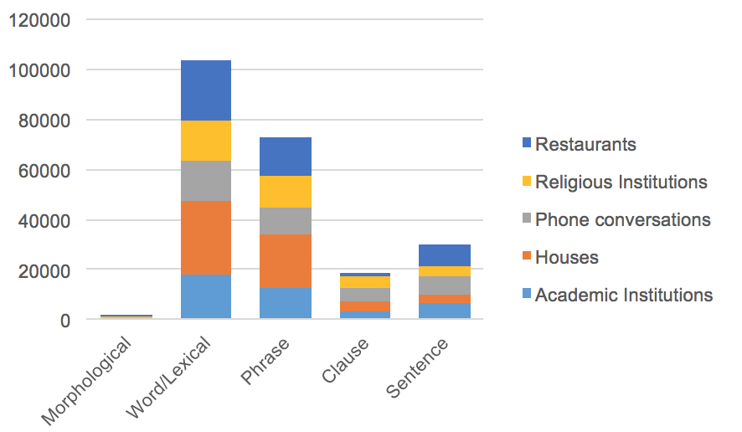

Figure 1. This is your figure title and/or description

References

Appel, R., & Muysken, P. (1987). Language contact and bilingualism. Amsterdam: Amsterdam University Press.
Abastillas, G. (2015). Divergence in Cebuano and English code-switching practices in Cebuano speech communities in the central Philippines (Unpublished Master's Thesis). Georgetown University.
Ang See, T. (1997). The Chinese in the Philippines: Continuity and change. Asian Studies, 33, 69-82.

[Note: Follow the APA 7th edition for in-text citations and the text-end references; Guidelines can be found here: https://owl.purdue.edu/owl/research_and_citation/apa_style/apa_formatting_and_style_guide/apa_changes_7th_edition.html

Appendix A. Sample Title

1SG – first person singular
2SG – second person singular
3SG – third person singular

